Topic 2: Alpha Drivers and Beta Drivers

Chapter 1: What is an alternative class?

- Describe super asset classes

- Capital Assets. Defined by their claim on the future cash flows of an enterprise. Hedge funds, private equity, credit derivatives, corporate governance funds. They can be valued using NPV.
- Assets that can be used as economic inputs: Consumable or transformable assets. Grains, metals, energy, livestock.
- Assets that store value: art, gold and precious metals.

- Describe the asset allocation process and compare strategic (SAA) and tactical asset allocations (TAA)

Strategic Asset Allocation (SAA) is interested in long term mix
- Investment decision with a long-term perspective
- Investment decisions that do not emphasize current market conditions
- Investment decisions that do not depend on the ability to diversity
- Focus on funds – for pensions etc.
Tactical Asset Allocations (TAA) is interested in the short-term mix.
- Investment decisions with a primary goal of maximizing return
- Short term in nature

- Compare efficient VS. inefficient asset classes and explain their relationships with traditional and alternative asset classes.

- Stock and bonds are the most efficient
- If there were no inefficiencies – then there would be no need for active management
- Alternative assets have intermediaries. LLs, LLCs, SPVs

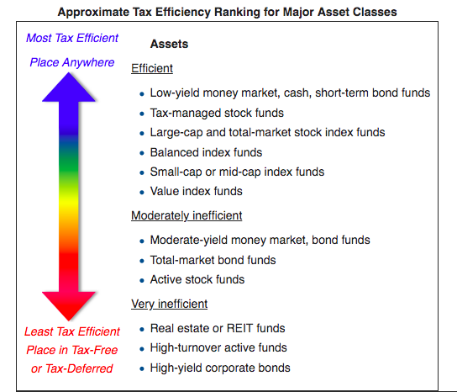

- Compare constrained versus unconstrained investing

- Constrained investing: is constrained by efficient benchmarks that reflect the “asset box” approach.
- Unconstrained investing: Lately, investments can invest outside of box. Japan – with zero interest rates have been forced to turn to alpha drivers.
- Unconstrained investing is an investment style that does not require a fund or portfolio manager to adhere to a specific benchmark. Unconstrained investing allows managers to pursue returns across many asset classes and sectors.

- Compare asset location and trading strategy

- Fung and Hseih show that MUTUAL funds’ economic exposures are defined more by where they trade. Hence, you get things like Small Cap, Large Cap, Active equity funds.
- Fung and Hseih show that HEDGE funds’ economic exposures are defined more by how they trade with the asset class. Hedge Fund managers have much greater turnover in their portfolios then mutual funds have.

- Compare asset class risk premiums Vs. trading strategy risk premiums

- Traditional investors can gain returns on where they invest. Large cap, small cap, and the high-yield bond market
- Strategies such as convertible arbitrage, statistical arbitrage, and equity market neutral can earn a so-called complexity risk premium
- Empirical research by William Fung and David Hsieh has shown that mutual fund returns are primarily derived from asset class risk premiums, while hedge fund returns are primarily derived from trading strategy risk premiums.

Chapter 2: Why Alternative Asset Classes are important: Beta Drivers and Alpha Drivers

- Describe the asset allocation process and compare strategic (SAA) and tactical asset allocation (TAA)

SAA
  - Not designed to beat the market
  - Board of Trustees of a Pension Fund, Endowment, or Foundation establishes the SAA among the major asset classes
  - Designed to meet the long-term funding goals of the organization which includes paying retirement, university budget, philanthropy
TAA
- Seeks extra return

- Explain and identify beta drivers and alpha drivers as investment products

Beta Drivers
- Passive Index (index)
- Enhanced Index (semi-active)
- Long Only
- 130/30

Alpha Drivers
- Long/short investing
- Absolute return strategies – focuses on return regardless of Short or Long
- Market segmentation
- Concentrated portfolios – hug your benchmark and maintain well-diversified portfolios.
- Nonlinear return processes – using options
- Alternative / cheap beta – examples are commodities or real estate. Gaining access to a new source of systematic return.
- Note: Alpha is not static. It can morph into Beta.

- Explain the application of beta and alpha drivers in constructing investment portfolios

- First, investors should reduce their reliance on beta drivers for excess return generation and rely more on alternative assets that have the highest alpha content.
- Second, an institutional investor should commit the investment staff resources toward those alternative assets and trading strategies believed to add value.
- Build teams at your fund that bridge asset classes.

Think outside the benchmark.
- Recognize that alpha need not be captive to beta
- Recognize that alpha may be generated across asset class boundaries
- Consider the risk of failing to outperform a peer group
- Pursue alternative assets where you have the greatest informational advantage.

Chapter 3: The Beta Continuum

- Compare various types of beta investment products or trading strategies classical, bespoke, alternative, fundamental, cheap, active, and bulk, and explain how each type is typically constructed


- Classical (expected return between the stock and the market)
- Historical data is used. That is why it is known as ‘historical’ beta.
- The Beta that you grew up with.
- Typically defined with reference to a broad stock market index
- Bespoke (local companies)
- Local returns. ETFs which focus on the Russell 2000.
- Small Caps
- Bespoke was the name for tailors.
- Local style. Local businesses.
- ETFs are the best example of this
- Alternative (currency)
- Using ETFS like currency and corporate bonds (find other sources of Beta)
- Finding returns from other sectors. Currency and Corporate Bonds.
- Find other sources of Beta.
- This is a new form of beta which has sprung up in the last few years
- Alternative source of corporate returns or something?
- Fundamental Beta (predicted value of beta depending on company values)
- New form of beta spurred on by the research of Arnott, Ksu, and Moore called fundamental indexation
- Fundamental beta is a form of endogenous alpha, alpha embedded within the index construction itself to outperform traditional capitalization-weighted benchmarked.
- Capitalization-weighted stock indexes have an inherent inefficient because they force index providers to purchase more stocks that have a higher weighting in the index (which may be undervalued).
- The goal of these indexes is to capture a systematic risk premium tied to a fundamental economic driver of corporate performance instead of a company’s market capitalization weight.
- Cheap Beta
- You can invest in exotics to find cheap beta.
- Beta can be embedded as a complex security. Convertible debts are a mix of debt and equity.
- The search for undervalued risk premiums embedded within complex securities such as convertible bonds
- Cheap beta refers to getting exposure cheaply, for example, through exchange-traded funds (ETFs) that track indexes such as the S&P 500.
- Active Beta (quants)
- Quantitative Trading
- Constitutes the world of products that use quantitative tools and models to capture so-called systematic irregularities in the equity markets
- Quant active. 130/30 and enhanced index products, where tight risk control maintains a beta exposure close to 1 with the benchmark while adding some form of enhanced return.
- The most popular is the 130 / 30 funds
- Bulk Beta (the most ACTIVE)
- Incorporates the most amount of active risk taking along the beta continuum, but still retains more beta exposure than alpha exposure.
- The heart of the active management industry
- There is a considerable amount of systematic risk contained within their returns, but the trade-off is that there is a large capacity for assets under management.
- Bulk beta products produce a linear relationship with their stated benchmark.

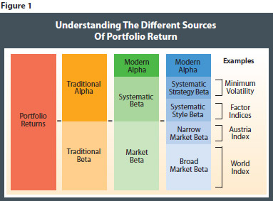

- Describe the proper way to estimate the alpha of an investment product

- Alpha is a measure of an investment’s performance relative to a benchmark, beyond what would be predicted by beta.

- This benchmark is commonly the S&P 500, but Fund Manager allows you to assign any investment as the benchmark.

- Given available information on factor returns and factor exposures, calculate alpha of investment products.

- alpha = R – Risk_{free} – B(Factor1 – Risk_{free}) – B(Factor2 – Risk_{free})

Chapter 4: Alpha versus Beta

- Describe product innovators VS. process drivers and balanced mandate asset managers in asset management industry

Product Innovators
- finely tune beta separation
- ETFs
- Hedge Funds
- TAA
- Alternative Betas
- High alpha- content active strategies

Process Drivers
- Deliver beta as cheaply and efficiently as possible
- Building an index in a large-scale fashion

“beta grazers VS. alpha hunters”.

- Explain why multi-factor alpha determination models may fail to provide accurate estimates of alpha, describe its implications for asset managers, and explain how the alpha estimation process may be improved.

- If we forget to include a relevant beta factor, then the alpha component could be artificially high.
- Asset managers must be rigorous and intellectually honest about what is beta and what is alpha
- An information asymmetry exists between asset managers and asset owner.
- To improve things – have the manager put his own money at risk.
- Investor has a reputation to protect
- Due diligence may reveal some of these hidden risks

- Argue why alpha may or may not be a zero-sum game

The answer is “Yes” if only
- Investors have the same horizon
- Investors have the same risk tolerance
- Investors are allowed the same access to all the asset classes
- Investors have the same expectation
- Investors pay the same tax rate (cannot be progressive or regressive)

- Describe the risks associated with information asymmetry in the asset management industry and explain how governance models can address these risks

- Transparency is the key for any governance
- Most do not consider ‘governance’ as alpha.

- Describe the four business models that are likely to be available to asset managers in the future

- Focus on Beta Driven Products
- Focus on Alpha Drivers
- Become an investment solutions provider (one-stop shop thing. Citigroup example)
- Evolve into a multi-boutique (this was asked on practice exam)

Chapter 5: The Calculus of Active Management

- Describe and calculate an ex-post information ratio.

- Return of active manager – Return risky Benchmark / Tracking Error
- The ex-post (looking backward) information ratio is a measure of achievement. It can be used to evaluate active manager's performance. It can be negative.
- Almost always reported on an ex-post basis.
- It is also known as appraisal ratio.

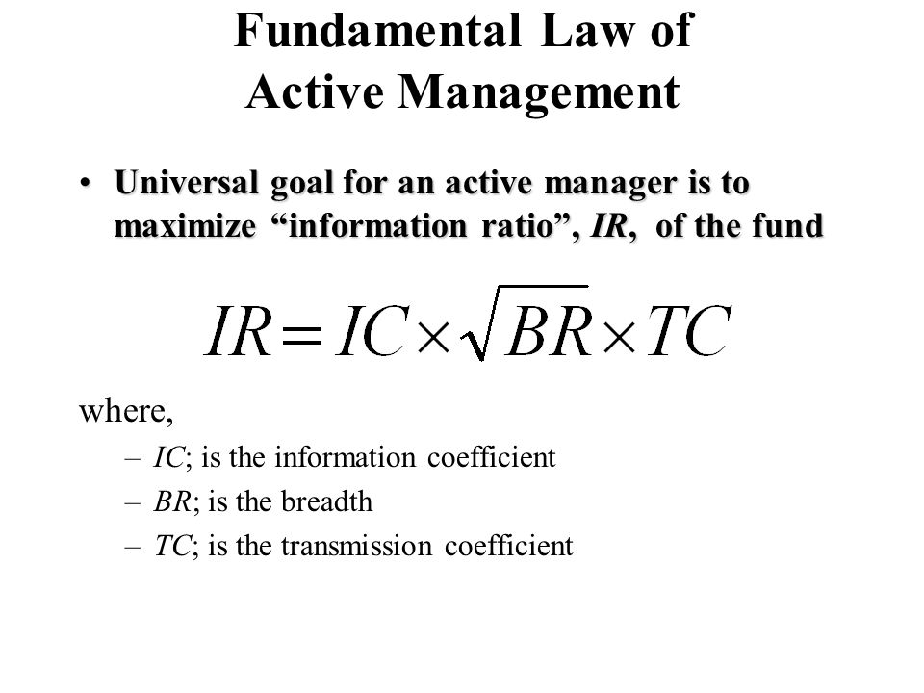

- Generally, information ratio is reported in the fact sheet of the mutual funds. If the information ratio of a mutual fund is negative, it indicates that the mutual fund manager was unable to produce any excess returns at all.
- An information ratio of less than 0.4 means that the mutual fund could not produce excess returns for a sufficiently long time and the fund may not be a good investment. If the information ratio is between 0.4 and 0.6, it is considered to be a good investment and an information ratio between 0.61 and 1 is considered as a great investment.

The full fundamental law is intuitive. The expected active return is the product of four key parameters:

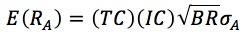

- The transfer coefficient, which measures the structuring of the portfolio
- The information coefficient, which measures the manager's skill
- Breadth, which measures the number of independent, active decisions available to an active manager per year
- Portfolio active risk, which measures the level of aggressiveness

- Explain why the Sharpe ratio is not an appropriate performance measure for individual managers and calculate whether a new manager should be added to a portfolio.
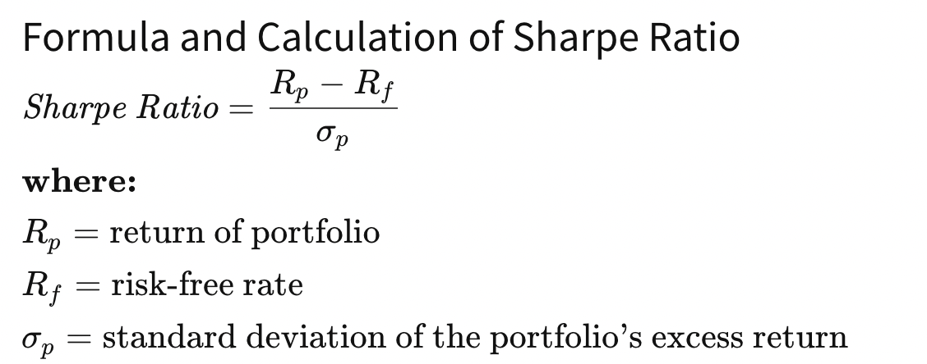
- Sharpe ratio is only appropriate for stand-alone investments. IR is different because the ratio is measure relative to some other benchmark.
- Sharpe is ONLY appropriate for comparing stand alone investments
- Based on MEAN Variance approach of Markowitz

- Describe and apply the relationship between the t-statistic and the information ratio

- Since the parameters have to be estimated, the resulting IR is subject to estimation risk.
- This means the true value of IR may or may not be difference from its estimated value
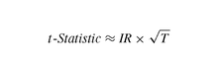

- Understand and identify the components of the information ratio on an ex-post and ex ante basis.

- Ratio calculated before and after
- The ex-post (looking backward) information ratio is a measure of achievement. It can be used to evaluate active manager's performance. It can be negative. The ex ante (looking forward) information ratio is a measure of opportunity.

- Calculate an ex-ante information ratio

- IR of an active manager is measure as the alpha / tracking error.
- The Information ratio is a measure of the risk-adjusted return of a financial security (or asset or portfolio). It is defined as expected active return divided by tracking error, where active return is the difference between the return of the security and the return of a selected benchmark index, and tracking error is the standard deviation of the active return, i.e., the information ratio IR is:
- Explain and calculate the weights of active positions in optimal portfolios

- See calculator document***
- The higher the alpha – the higher the weight.
- The higher the risk aversion parameter, the greater the weight assigned to reducing the total volatility of active positions.
- This assumes that the manager is only concerned with mean and variance of active risk
- There is a tradeoff between the IC and Breadth
- IC = Skill

- Describe the process for the construction of benchmarks for alternative assets and identify the variables that affect the ex-post information ratio in this approach

- Unlike traditional long-only stock and bond asset managers, alternative investment managers do not have a mandate to follow a benchmark.
- Investors may have to create custom-made benchmarks – the simplest method to do so is to use the Sharpe style analysis approach.

- Discuss the roles of the transfer coefficient (TC) in measure in the ex-ante information ratio and explain the impact of the transfer coefficient on the information ratio of the traditional and active management products

- The transfer coefficient, defined precisely, is the cross-sectional correlation coefficient between risk adjusted active weights and risk adjusted forecasted residual returns in the portfolio.
- TC is a measure of the efficacy of translation active portfolio forecasts into real portfolio bets.
- The information coefficient measures the strength of the return-forecasting process, or signal, and the transfer coefficient measures the degree to which the signal is transferred into active portfolio weights.
- The long-only constraint on investing has been recognized as the most restrictive portfolio requirement in the asset management industry.
- Grinold and Kahn refer to this as a “knock-on” effect because you have to underweight other longs in the portfolio.
- The Long Only constraint can reduce the TC (and the IR) by 40%.
- Always less than 1.

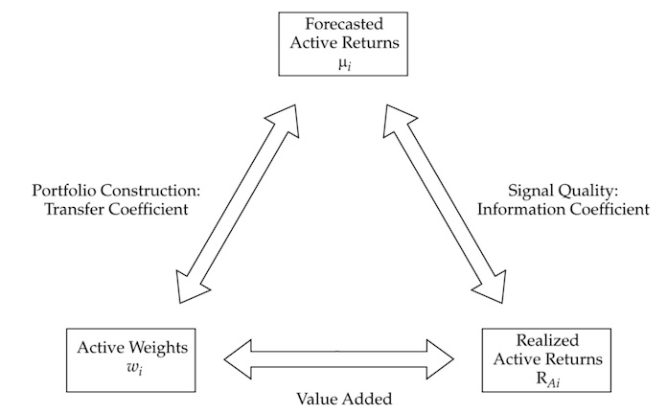

- Describe 130/30 portfolios and explain how they are constructed and why they have attracted attention.

  - Within the last 3 years there has been an explosion of the 130/30 portfolios.
  - Similar to long only funds – in that they are constructed to beat the long-only products.
  - These products start by allocating 100% of NAV to long positions in the equity markets.
  - They differ from the traditional products to the extent that they can sell short equity securities, typically up to 30%.
  - For the 130/30 products, an investor typically pays a management fee of around 1%. Far reach from the 2% - but the funds themselves can reach into the billions.
  - So, very neutral and it becomes a Relative Arbitrage

